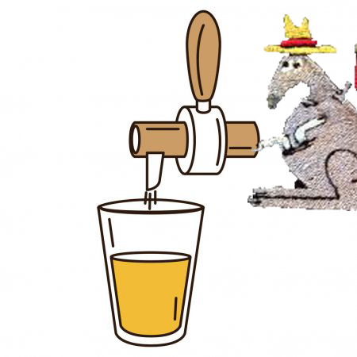
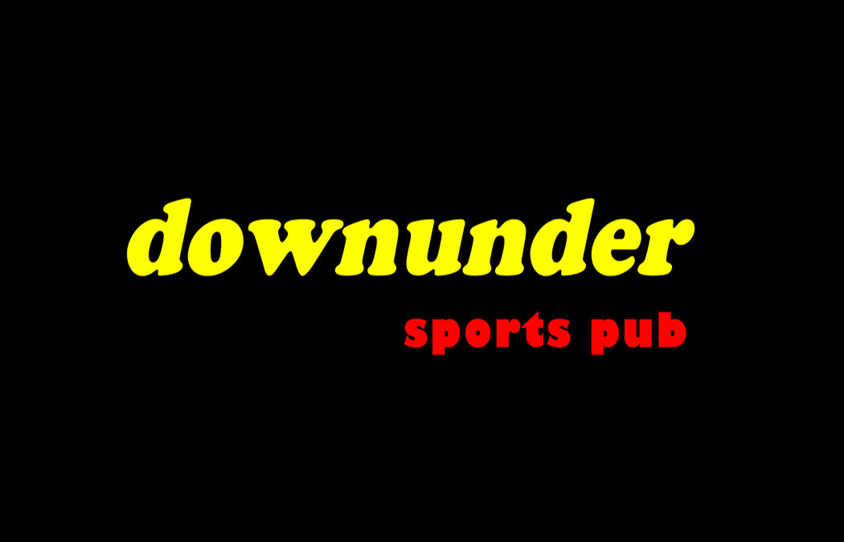

Draft SPECIALS

Geaghans Smiling Irish Bastard $4.00
Bigelow Brown Ale $4.00

IPAs
Marsh Island Tropical Breeze 7.2%
Cushnoc Gigantic Dad Pants 7.5%
Masons Hipster Apocalypse 5.7%
Banded Brewing Veridian 6.0%
Boothbay Harbor Thirsty Botanist 7.0%
Maine Beer Water & Woods 6.2%
OBC Tubular 7.2%
Lonepine Brightside 7.1%

And… there’s more

Marsh Island Green Growth Pale Ale 5.7%
Stella Artois 5%
Geaghans Higgins Irish Red 5.5%
Bunker Brewing Machine Czech Pilsner 5.2%
Allagash Black Dark Ale 7.5%
Allagash White 5.2%
Seadog Blueberry 4.6%
Sam Adams Octoberfest 5.3%
Bud Light 4.2%

Coming Soon
Funky Bow Jimmy’s Juiced Up
Sierra Nevada Hazy Little Thing
First Mile Blueberry Wit
First Mile Map 67
Masons Liquid Rapture
Lonepine OH J
Marsh Island Downrigger IPA

Drink Menu
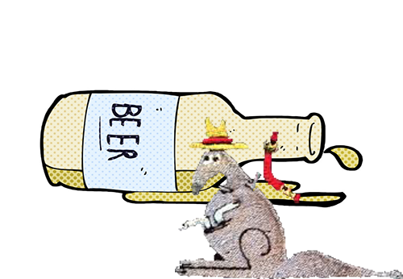

Sam Adams Porch Rocker
Sam Adams Boston Lager
Seadog Blueberry Seltzer
Marsh Island Island Escape
Bud Light
Bud Light Lime
Blue Moon
Budweiser
Miller Lite
Coors Light
Michelob Ultra
Corona Extra
Smirnoff Ice
Guinness
Heineken
Mikes Hard Lemonade
Twisted Tea
Twisted Tea Half & Half
Angry Orchard
O’Douls NA

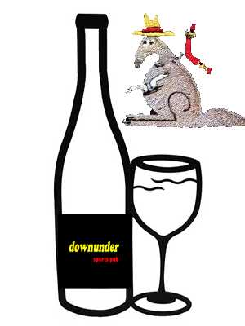

Santa Marta Pinot Grigio B $21 G $9
Smoking Loon Merlot B $21 G $9

Yellowtail Pinot Grigio G $7
Yellowtail Chardonnay G $7
Yellowtail Moscato G $7
Yellowtail Merlot G $7
Yellowtail Cabernet Sauvignon G $7
Barefoot White Zinfandel G $7

MORE SPIRITS

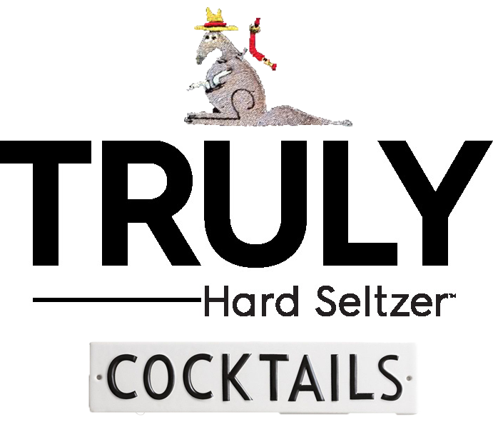

Raspberry $5
Truly Berry. Razzmatazz. Raspberries
-
Raspberry Lime $5
Truly Berry. Razzmatazz. Lime Juice. Limes

Berry Cream $6
Truly Berry. Whipped Vodka.
Cranberry. Raspberries

Explosion $6
Truly Berry. Blueberry Vodka.
Lime. Orange. Lemon

Truly Spritz $6
Truly Berry. Orange Aperol. Pomegranate Juice
Strawberries. Lemon

Sage $6
Truly Berry. Vanilla Vodka. Lemon Juice
Blackberries. Sage Leaves

Truly Mule $7
Truly Berry. Pomegranate Juice. Raspberry Vodka
Lemon. Lime. Ginger Beer

A Truly Great Sangria $8
Truly Berry. Moscato. Whipped Vodka
Razzmatazz. Strawberries. Raspberries

Truly Raspberry Mojito $8
Truly Berry. Flavored Rum. Razzmatazz.
Raspberries. Mint. Lime. Simple Syrup

SpicyRita $8
Jalapeno Infused Tequila. Triple Sec. Jalapenos
Raspberries. Lime Juice. Mix. Limes

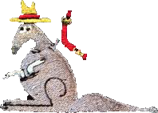

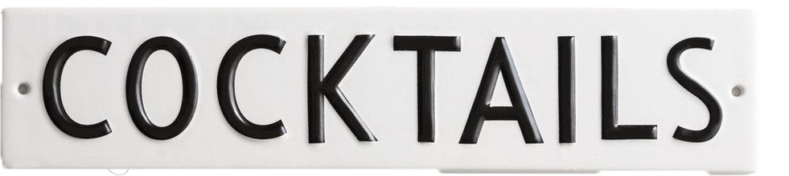

Caramel Apple Cider $7
Caramel Vodka. Apple Cider. Orange

Downunder Juice $8
22 Vodka. Malibu. Peachtree
Cranberry. Pineapple

Sydney Martini $8
Absolut Citron. Cointreau. Lime

Raspberry Margarita $8
Tequila. Razzmatazz. Bar Mix
Raspberries. Limes

Seasonal Sangria (Fall) $8
Cabernet. Apple Brandy. Peach Brandy Apple Cider. Pomegranate Juice.
Oranges Cinnamon

downunder Signature Bloody $9
Vodka. Bloody Mary Mix. Celery Salt.
Salt/Pepper. Worcestershire. Tabasco.
Bacon. Celery. Dirty Shrimp. Olives. Lemon

FOOD CORNER

Shrimp Rangoon Dip $9
Pub Cheese & Crackers $6.95
Soup: Corn Chowder $5
Dessert: downunder Sundae $6.95
Pizza Munchie $8.99

Don’t’ forget!
Thursday: 25% Off Bone-In Wings

